/* july 25*/

/*alises and aggregate function*/

select max(salary) as maxsal from emp as employee where ename like '%i%' and date_new='2020-04-20';

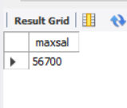

select count(ename) as empcount from emp where city in('pune','satara') and designation='ceo';

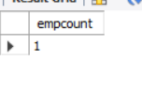

/*group by clause*/

select count(eno),city,city2 from emp group by city,city2 ;

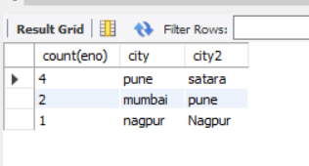

select count(ename),designation from emp group by designation;

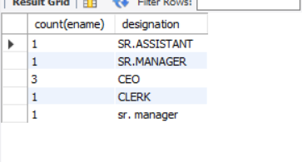

select max(salary),city from emp group by city;

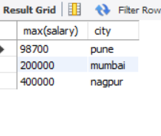

select sum(salary),city from emp where salary>50000 group by city ;

